Choose 3 major events in the story. Then, for EACH EVENT, in 3 to 5 sentences describe what happens and how the event influences the characters in the story to act. You will have a minimum of 9 sentences when you complete this task, and a maximum of 15
Ex: | (From Of Mice and Men) George Kills Lennie-At the end of the novel, George realizes that Curley, in all of his anger, is going to torture Lennie to death. In recognizing this, George comes to terms with the fact that he should be the one to quickly and painlessly kill Lennie; though, he also realizes that in doing so, he will lose his best friend and the dream they share of owning a farm. George ends Lennie’s life anyway, even though the hope he has for the future is concurrently destroyed.
Event 1:
Event 2:
Event 3:

Choose 1 minor character from the story. In 3-5 sentences, describe how the actions and decisions of this character impact any of the following: another character, a relationship, a conflict, a future plot event. You will have a minimum of 3 sentences when you complete this task, and a maximum of 5.
Ex: | Candy’s Dog-When George and Lennie originally meet Candy, he’s followed by a decrepit k9 who not only moves slow but has no teeth and smells foul. In fact, the dog is consistently criticized by the other bunkmates due to its tangible stench and failing health, to the point where many of them petition Candy to put the dog out of its misery. Upon such a suggestion, Candy reminds his colleagues that the dog was such a great sheep dog in its prime; however, the bunkmates challenge him to notice how the dog’s current quality of life is only getting worse than it already is. Upon deep consideration, and the offer of Carlson, Candy reservedly allows Carlson to shoot the dog in the back of the head so that it, as Carlson suggests, won’t even feel it. As this happens, Candy slumps into his bed—devastated—and even later reflects that he should have been the one to mercifully put down his own dog.
Minor Character:

Identify 2-4 major conflicts and their resolutions in the story. In 3 to 5 sentences describe EACH conflict and how each one reaches its resolution. You will have a minimum of 6 sentences when you complete this task, and maximum of 20 sentences.
1.
2.
3.
4.

Identify 2 important settings in the piece. In 3 to 5 sentences, describe EACH setting and explain how each one influenced the plot events or characters in the story. You will have a minimum of 6 sentences when you complete this task, and a maximum of 10.
1.
2.

Identify at least one symbol (and motif if possible) in the piece. In 3 to 5 sentences, describe the symbol (and/or motif) and explain how it relates the story. You will have a minimum of 3 sentences when you complete this task, and a maximum of 10.
Symbol 1:
Symbol 2:
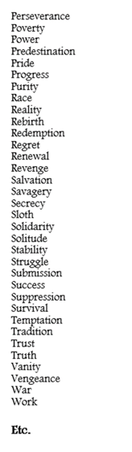
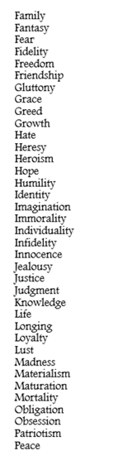
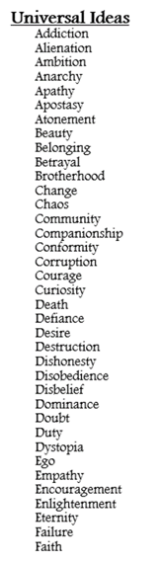
Identify and List 5-7 Universal Ideas that this story relates to. (see the image to the right)

Write at least 3 universal insight (thematic) statements for this piece. Make sure that at least one contains the phrase “that although”
Use the following template for a Universal Insight Statement (3 minimum)
(Author) writes (Title) in order to illustrate that (idea)(a truth about said idea that is true for most, if not all, individuals). Most universal insights relate at least two universal ideas.
Ex: | Steinbeck illustrates that true companionship often requires immense sacrifice.  Steinbeck illustrates that although the American Dream is enticing and promises future ease, it’s completely unattainable.
1.
2.
3.

Include ONE quick, impactful quote that in some way relates to your story and record it here. (NOT from the text itself)
Ex: | “For many, the American dream has become a nightmare.” -Bernie Sanders, US Senator
Quote:

